Login Instructions for Students
What is my ECCC Student Email Address?
first name.last name + last 4 digits of student ID# + @students.eccc.edu
Example: Jane Doe with ID# of 123456.
Email address would be: jane.doe3456@students.eccc.edu

What is my initial ECCC password?
Ecc- + uppercase first letter of first name + uppercase first letter of last name + last 4 digits of SSN
Example: Jane Doe with SSN of 123456789.
Password would be: Ecc-JD6789
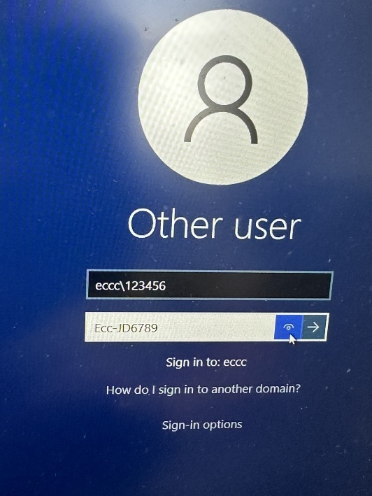
How do I login to a computer on campus?
Login using ECCC\student id # and password above.
Example: ECCC\123456

How do I login to myec, Canvas, EC email, and more (Single Sign On)?
Go to https://myapps.microsoft.com/eccc.edu
Login using student email address and password above.
Forgot Password? Go to https://myapps.microsoft.com/eccc.edu and click on the ‘Can’t access your account?’ link. Follow the on-screen prompts to reset your password.
Still can’t login? Email: ithelpdesk@eccc.edu

